**Cultural plan**

**for***add the child’s name and date of birth*

Name :

Date of birth:

1. **Your mob**

(Identification)

You are Aboriginal / Torres Strait Islander / Aboriginal and Torres Strait Islander

A genogram of your family is attached to this plan. It has *<insert correct number>* generations of your family.

*Attach the genogram as it stands, even if there are gaps. If the genogram does not extend to at least* ***three generations*** *(child’s/parents’/grandparents’ generations) explain here where family finding is up to, and what still needs to happen.*

*Sections 2 and 3 relate to the child’s identity and connection. It is important to consult with Aboriginal people to gather this information, ensuring it is accurate. Seek advice from the Senior Advisor- Aboriginal Cultural Planning as required. It is part of their role to assist with overcoming any barriers to developing this plan*



1. **Where you are from**

(Cultural identity)

Your Clan/Nation:

Your Language group:

Your Totem:

Your Land and/or Water:

1. **Cultural connections**

*Understanding our heritage provides us with an understanding of how we belong in the work and helps to strengthen connections to family and community.*

*What do we know about the Country of the child’s parents?*

*Is further information about the child’s/young person’s family required?*

Story of your mother’s country:

Story of your father’s country:

History of the community where you live:

Your cultural journey so far:

*How strong is the child or young person’s existing cultural connection? Have they returned to Country? How is the child’s traditional ownership status supported? Does the child have confirmation of Aboriginality?*

**How is it going for you?**

*Include here the child or young person’s reflections about their own cultural journey so far. For example, the child may want to include a drawing or photograph of their art work or a cultural event they have attended.*

*You could ask them:  
What activities have you participated in? What have you learnt about your family and culture? What are you most proud of? What helps you feel that you belong to your community?*

1. **Your family contacts and significant relationships**

**Parents**

|  |  |  |
| --- | --- | --- |
|  | Mother | Father |
| Name |  |  |
| Aboriginal/Torres Strait Islander |  |  |
| Clan |  |  |
| Language |  |  |
| Level of contact |  |  |

**Siblings**

|  |  |  |
| --- | --- | --- |
| Name | Relationship to you | Detail and level of contact |
|  |  |  |
|  |  |  |

**Other key family members**

*Include aunts, uncles, grandparents, sister cousins and brother cousins, and other extended family members.*

|  |  |  |
| --- | --- | --- |
| Name | Relationship to you | Detail and level of contact |
|  |  |  |
|  |  |  |

**Other people significant to the child**

|  |  |  |
| --- | --- | --- |
| Name | Relationship to you | Detail and level of contact |
|  |  |  |

1. **What you would like to learn about and connect with**(Cultural aspirations)

*Check with the child or young person about the various aspects of their connection to their culture. For example, you could ask:*

*What more would you like to learn about your family and culture? Is there family you would like to meet or spend time with? What cultural activities would you like to participate in? What makes you proud to be Aboriginal? What would help you feel more strongly that you belong to your community?*

1. **How we are keeping you connected**

*This section is about identifying activities that will help nurture and support the child or young person while strengthening their identity and cultural connections. Include arrangements for activities and experiences that will support and preserve the child’s cultural identity and connection to the community they live in. If there is no need for a particular table, it may be deleted. If*

**Your cultural mentor:**

*Does the child have access to an Aboriginal role model or a mentor? Who can be the child’s primary source of cultural authority? Is it contact with an Aboriginal parent (where the culture of origin is known)? Is it contact with an Aboriginal relative who has a lineal cultural connection to the Aboriginal parent? Is it contact with an Elder who is from the same cultural group as the biological Aboriginal parent? Is it contact with another Aboriginal community member who is from the same cultural group as the biological Aboriginal parent? If the child has a mentor, record this here. If not, describe what steps will be taken, by whom and when, to identify and connect the child with a mentor who can be a primary source of cultural authority for the child.*

**Direct cultural connection**

*This is where the child spends time with their own Aboriginal community and culture to strengthen their connection to and deepen their knowledge of their own Aboriginal community. Does a Return to Country need to take place? What support do you need to complete this work?*

|  |  |  |  |  |
| --- | --- | --- | --- | --- |
| **Goal** | **Tasks** | **Responsibility** | **Timing/frequency** | **Notes/Comments** |
|  |  |  |  |  |
|  |  |  |  |  |

**Cultural socialisation**

*This is where the child spends time in the Aboriginal community in general (rather than their own Aboriginal community). This may include Aboriginal holiday programs and NAIDOC week events.*

*Is the child engaging or participating in cultural sports or recreational activities, documentaries, movies or music about Aboriginal culture? Does the child have access to Aboriginal learning materials, including storybooks and puzzles? How will the child interact with and participate in the local Aboriginal community?*

|  |  |  |  |  |
| --- | --- | --- | --- | --- |
| **Goal** | **Tasks** | **Responsibility** | **Timing/frequency** | **Notes/Comments** |
|  |  |  |  |  |
|  |  |  |  |  |

**Health**

*Include any goals and tasks specific to cultural support that relate to promoting the child or young person’s health. These should complement, but not duplicate, goals in the health area of the actions table related to implementing the child’s case plan. For example, do they access ‘Closing the Gap’ initiatives or Aboriginal health services?*

|  |  |  |  |  |
| --- | --- | --- | --- | --- |
| **Goal** | **Tasks** | **Responsibility** | **Timing/frequency** | **Notes/Comments** |
|  |  |  |  |  |
|  |  |  |  |  |

**Education**

*Include any goals and tasks specific to cultural support that relate to the child or young person’s education. These should complement, but not duplicate, goals in the education area of the actions table related to implementing the child’s case plan.* *For example do they have a cultural or peer mentor or support from a Koori Education Support Officer?*

|  |  |  |  |  |
| --- | --- | --- | --- | --- |
| **Goal** | **Tasks** | **Responsibility** | **Timing/frequency** | **Notes/Comments** |
|  |  |  |  |  |
|  |  |  |  |  |

**Developmental support**

*Include any goals and tasks that will strengthening the child or young person’s developing cultural identity and connections while helping to nurture and support their general development. These should complement, but not duplicate, goals in the developmental support area of the actions table related to implementing the child’s case plan. For example do they receive behavioural support that incorporates a cultural lens?*

|  |  |  |  |  |
| --- | --- | --- | --- | --- |
| **Goal** | **Tasks** | **Responsibility** | **Timing/frequency** | **Notes/Comments** |
|  |  |  |  |  |
|  |  |  |  |  |

1. **Creating a sense of belonging**

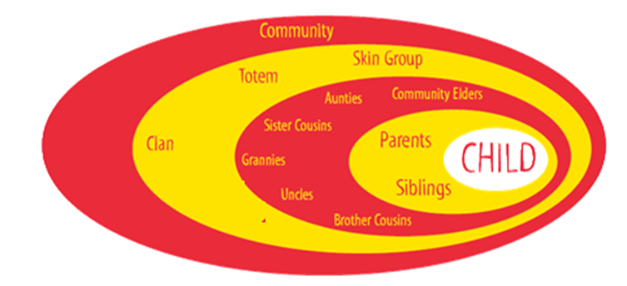

*Reflect on what has been included in this plan. Have you considered all of the aspects of belonging identified in the diagram above? Provide a brief summary here.*

**People who have committed to helping you with your cultural plan**

*List the key people who will put this plan into action with and for the child or young person.*

**People who have checked your cultural plan will meet your needs**

*This section shows the formal endorsement of the ACCO CEO and DHHS Case Planner.*

Signature: Date:

<Name>

Chief Executive Officer

<ACCO>

Signature: Date:

<Name>

Case Planner

<DHHS Office>

*The Department of Health and Human Services (department) accepts self-identification as Aboriginal as a sufficient basis for responding to the family as Aboriginal. This cultural plan has been developed to comply with section 176 of the Children, Youth and Families Act 2005 (the Act) that requires the department to provide a cultural plan to each Aboriginal child in out-of-home care. This document does not constitute confirmation of Aboriginality for any other purpose. Identification of Aboriginality in this plan extends to a person’s general acceptance as an Aboriginal for the purposes of the Act. It does not propose to suggest membership of a particular Aboriginal or Torres Strait Island community for any particular purpose (including Land Council membership).*